SunSmart communications with your school community.
Including information in your communications to parents/carers is a great way to educate and remind the school community about sun protection as the best form of skin cancer prevention.
Use these articles in your newsletters, social media channels or other communications. Tailor the content to suit the priority, time of year or communication style of your school.
Contents
SunSmart communications with your school community. 1
1. What is UV radiation? 2
2. UV is different from heat 2
3. Reduce your child’s skin cancer risk 3
4. Sun protection methods 3
5. When do I need sun protection? 4
6. What is a SunSmart hat? 4
7. How to choose a SunSmart hat? 5
8. Why a cap is not SunSmart? 5
9. Sun safety is everyone’s responsibility. 5
9a. Teachers/staff 5
9b. Parents/carers 6
10. Why our school only sells SunSmart hats 6
12. Correct sunscreen application (Infographic & video) 7
13. Can sunscreen cause skin allergies? 8

1. What is UV radiation?
Overexposure to ultraviolet (UV) radiation is the leading cause of skin cancer in Australia.
UV is a form of energy produced by the sun that can penetrate the skin and cause permanent damage to the cells below contributing to sunburn, skin ageing, eye damage, melanoma and other skin cancers.
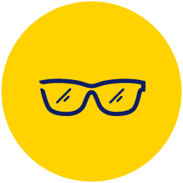
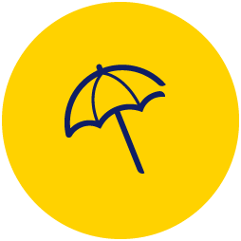
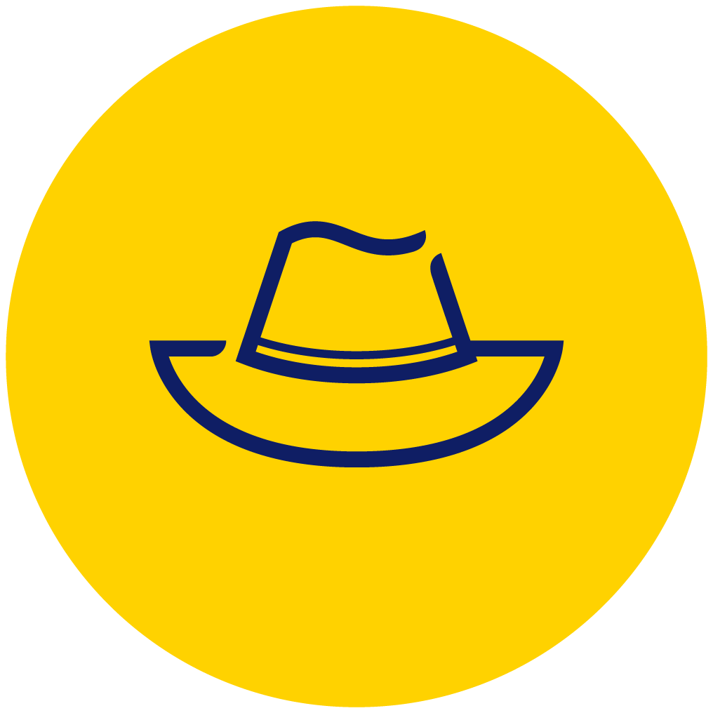
When you protect your skin, you reduce your risk of skin cancer. Remember to regularly:
SLIDE
SEEK
SLAP
SLOP

SLIP

2. UV is different from heat
Many people mistakenly believe that they only need sun protection on hot, sunny days. It is UV, not heat, that causes sunburn, skin damage and skin cancer.
UV is not like the sun’s light which we see, or the sun’s warmth (infrared radiation) which we feel. Our senses cannot detect UV so it can be damaging our skin without us knowing, even on cool or cloudy days.
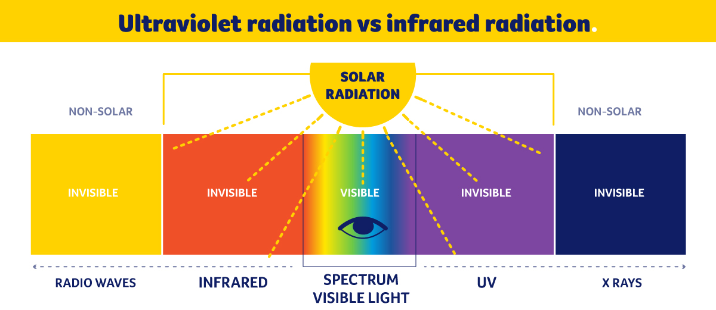
Download the free SunSmart App to find out when sun protection is recommended for your location.

3. Reduce your child’s skin cancer risk
Skin cancer is the most common cancer in Australia. Two out of three Aussie kids at school today will be diagnosed with skin cancer later in life—some of them with deadly melanomas. Ultraviolet (UV) radiation from the sun is the leading cause of skin cancer. Unprotected exposure of your child’s skin to UV significantly increases their risk of developing skin cancer later in life. When you protect your skin, you reduce your risk. When UV is 3 and above, remember to Slip, Slop, Slap, Seek and Slide!
To learn when the UV is going to be high enough to damage unprotected skin in your local area, download and check the free SunSmart App.

4. Sun protection methods
SA experiences levels of ultraviolet (UV) radiation high enough to damage unprotected skin for at least 10 months of the year - even on cool or cloudy days. Remember to Slip, Slop, Slap, Seek and Slide!
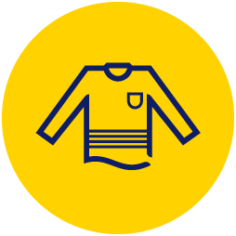
SLIP on sun-protective clothing

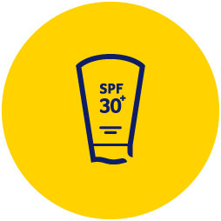
SLOP on SPF 30 sunscreen or higher
SLAP on a broad-brimmed or bucket hat

SEEK shade

SLIDE on some wrap-around sunglasses

5. When do I need sun protection?
Overexposure to ultraviolet (UV) radiation causes is estimated to cause 95-99 per cent of skin cancers in Australia. This means that when you protect your skin, you reduce your risk. We need to protect our skin whenever the UV levels are 3 or above, which is at least 10 months of the year across SA.
Download and check the free SunSmart App to know when you need sun protection based on your location. You can personalise it with your details including skin type, height and weight, and set up daily alerts to remind you when sun protection is required each day, as well as two-hour reminders to re-apply sunscreen.

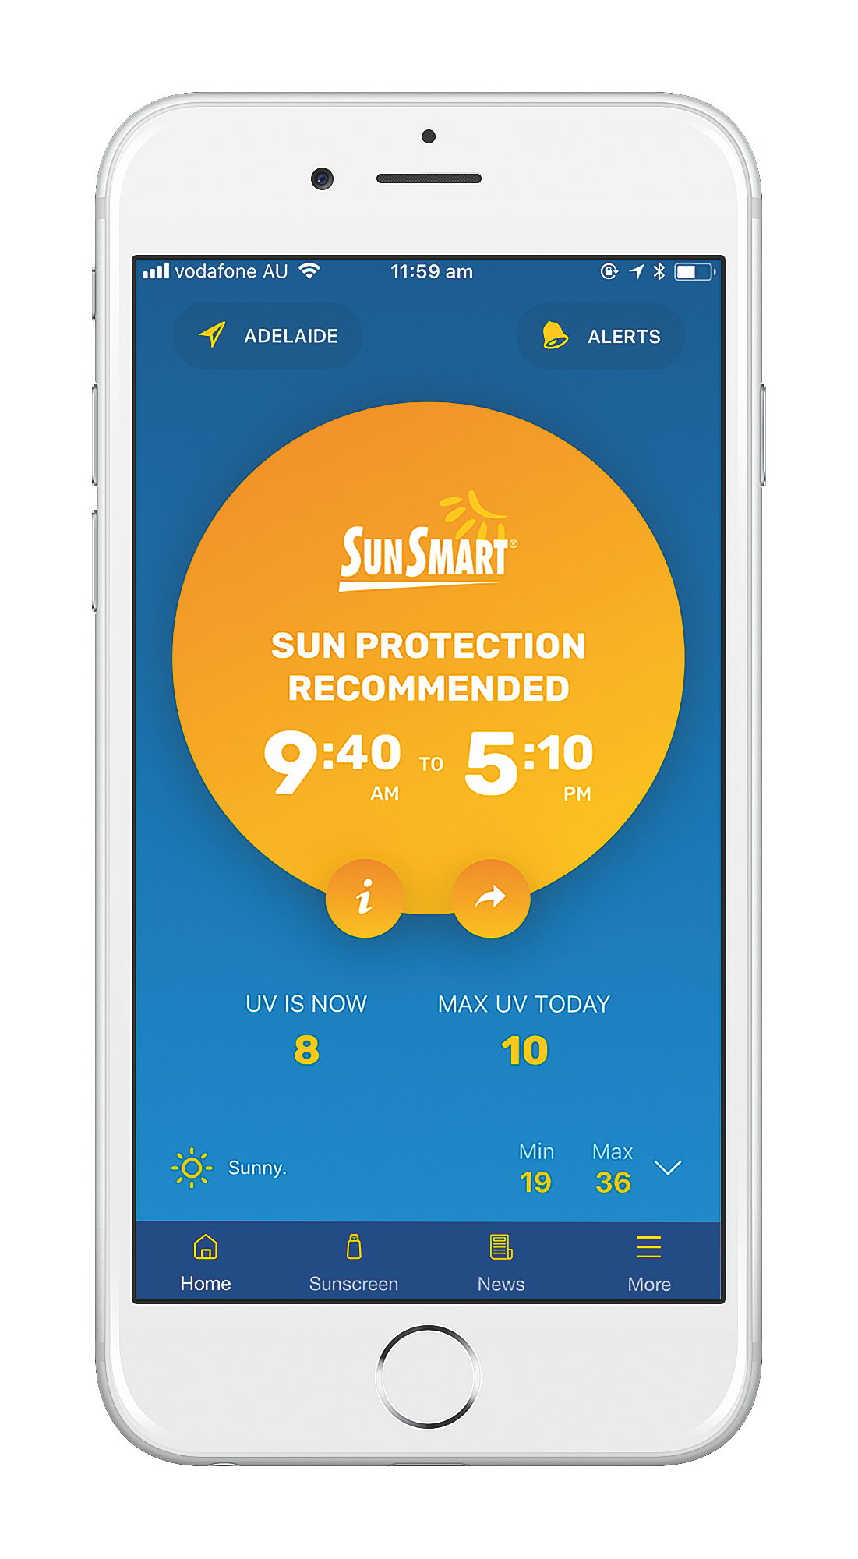

6. What is a SunSmart hat?
SunSmart hats are broad-brimmed hats, bucket hats, or legionnaire style hats. A SunSmart hat not only protects the face, head, neck and ears, it can also reduce the amount of UV radiation reaching the eyes by 50 per cent. For more information on SunSmart hats refer to Cancer Council SA's Fact Sheet on Sun Protective Hats.
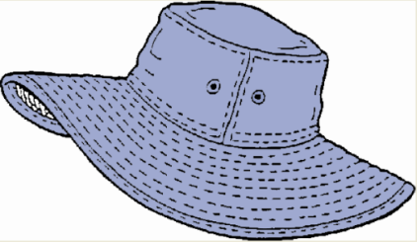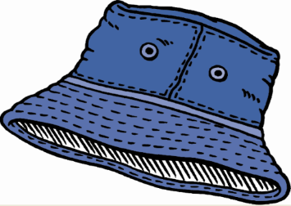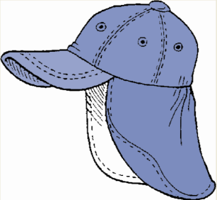
Broad-brimmed Bucket Legionnaire Style

7. How to choose a SunSmart hat?
A SunSmart hat protects the face, head, neck and ears and can reduce the amount of UV radiation reaching the eyes by 50 per cent. Make sure your hat is SunSmart by checking the following:
- Does the brim adequately shade the whole face?
- Is it made of a close weave fabric that prevents light getting through?
- Does it have a dark lining to reduce the amount of UV radiation being reflected onto the face and eyes?
- Does it fit correctly? Such as not sliding down the child’s face or easily blown off.
- That it is not a baseball cap or visor.
- Does it obscure vision? If so, this may pose a safety concern.

8. Why a cap is not SunSmart?
Baseball caps and sun visors are not recommended for good sun protection as they leave parts of the face, neck and ears unprotected from the sun’s harmful ultraviolet (UV) rays.
Our faces are exposed to the damaging effects of UV every day and ears, temples, lips and the nose are among the most common parts of the body for skin cancers to develop later in life.
And the sun’s rays don’t just damage skin – they can cause permanent damage to children’s eyes. A SunSmart hat, such as broad-brimmed, bucket or legionnaire style hats not only protects the face, head, neck and ears, it can reduce the amount of UV reaching the eyes by 50 per cent.

9. Sun safety is everyone’s responsibility.
9a. Teachers/staff
In Australia, we experience some of the highest ultraviolet (UV) radiation levels in the world, so if we want today’s children to have a healthy future, we need to equip them with good sun protection habits now.
As teachers, this means showing students how to be SunSmart through our own role modelling in the school environment. By ‘walking the sun protection talk’, not only will you be protecting yourself from harmful UV, you will also help normalise SunSmart behaviours by encouraging children to do the same whenever they step outside.

A handy tip is to keep a broad-brimmed hat and sunscreen in your bag or in your classroom, ready to grab whenever you head outdoors.
9b. Parents/carers
{ENTER SCHOOL NAME} is committed to the health and safety of your child. In Australia, we experience some of the highest ultraviolet (UV) radiation levels in the world. Overexposure to UV causes is estimated to cause 95-99 per cent of all skin cancers. Protecting our skin from UV is the simplest and most effective way to reduce the future risk of skin cancer.
As teachers, we are committed to showing students how to be SunSmart through our own role modelling in the school environment. However, research shows that children are more likely to use sun protection when their parents do.
By ‘walking the sun protection talk’, not only will you be protecting yourself from harmful UV radiation, you will also help encourage your child to do the same when they are out and about outside of school hours.
A handy tip is to keep a broad-brimmed hat and sunscreen in your bag, car or by the door, ready to grab whenever you head outside.

10. Why our school only sells SunSmart hats
At our school, we’ve decided to only sell SunSmart hats in the uniform shop.
Skin cancer is the most common cancer in Australia. Two in three people who grow up in Australia will be diagnosed with skin cancer. Overexposure to ultraviolet (UV) radiation is estimated to cause 95-99 per cent of skin cancers in Australia. This means that when you protect your skin, you reduce your risk. Protecting children’s skin from exposure to UV is the simplest and most effective way to reduce their future risk of skin cancer.
A SunSmart hat protects the face, head, neck and ears and it can reduce the amount of UV radiation reaching the eyes by 50 per cent. Baseball caps leave the face, neck and ears unprotected from the sun’s harmful UV. By only selling SunSmart hats, we’re taking an important step in protecting the long-term health of our students.
Students that are not wearing SunSmart hats at school will be asked to play in the shade. The school has information about sun safety and reminder systems in place to support students so that they regularly wear their SunSmart hat. Please contact us at {include contact information here} for more information if you have any questions.

11. Spare hat borrowing system
This term we are focusing on all students wearing SunSmart hats. Please help remind your child to bring their SunSmart hat to school.
We know that children can forget their SunSmart hat every now and then, so we’ve created a “spare hat borrowing system” to ensure all students can participate in outdoor play with their friends even when they have forgotten their own hat.
Borrowing a spare hat should be rare and if your child is consistently forgetful, we might need to help them in other ways. For further information about how we can help your child in this case, please contact us at {include contact information here}.

12. Correct sunscreen application (Infographic & video)
Sunscreen reduces the amount of ultraviolet (UV) radiation reaching your skin. Use SPF30 or higher broad-spectrum water-resistant sunscreen; apply it 20 minutes before going outside and re-apply every 2 hours or after any activity that may remove it (e.g. swimming, sweating, and towel drying). Cancer Council recommends that adults need to use a teaspoon (about 5ml) for the face, neck and ears; a teaspoon for each arm and leg; and a teaspoon each for the front and the back of the body. Adjust this amount for children based on their body size.
No sunscreen provides 100 per cent protection against UV radiation so remember to also protect yourself by wearing SunSmart clothing, a SunSmart hat, sunglasses and by seeking out shade when you can.
For more information about sunscreen refer to the Cancer Council SA's Fact Sheet on Sunscreen.
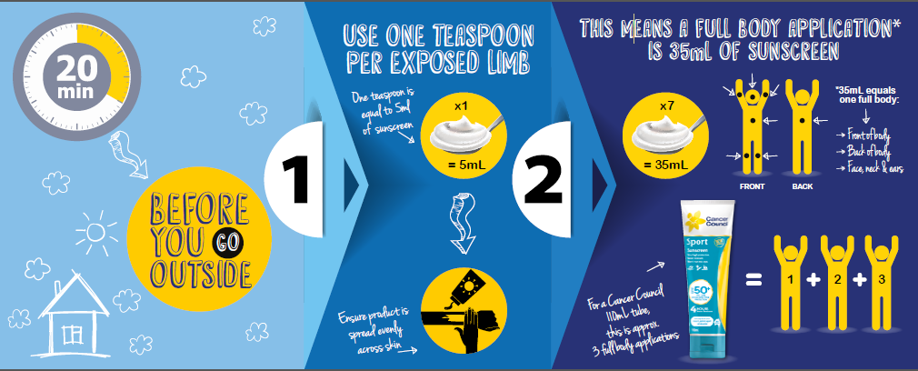

13. Can sunscreen cause skin allergies?
Allergic reactions to sunscreen are rare. Cancer Council recommends performing a usage test before applying a new sunscreen, where a small amount of the product is applied on the inside
of the forearm for a few days to check if the skin reacts, prior to applying it to the rest of the body. While the usage test may show whether the skin is sensitive to an ingredient in the sunscreen,
it may not always indicate an allergy, as this may also occur after repeated use of the product.
If a reaction occurs, discontinue use and seek advice from a doctor about choosing an alternative product.
For more information sunscreen reactions go to: https://www.cancer.org.au/preventing-cancer/sun-protection/sunscreen-reactions.html

