Sun protection is everyone’s responsibility.

1: Sun protection is everyone’s responsibility

Here in Australia, sun protection needs to be everyone’s responsibility. We experience some of the highest ultraviolet (UV) levels in the world, so if we want today’s children to have a healthy future, we need to equip them with good sun protection habits now.

2: 2 in 3 image

Skin cancer is the most common form of cancer in Australia.

Two in three people who grow up here will be diagnosed with some form of skin cancer in their lifetime. And the main cause of this is overexposure to UV radiation.

In SA, we experience UV levels high enough to damage unprotected skin most months of the year. This means that even in winter, if children are in the playground and the UV is 3 or above, they’re at risk.

3: 95-99 per cent of skin cancers are preventable

But it’s not all bad news. We know that 95-99 per cent of skin cancers are preventable if we regularly follow SunSmart behaviours.

These behaviours are the key to reducing the skin cancer risk for the kids in our school.

4: The importance of being SunSmart

First, I’d like to share why sun safety is important to me. It’s because… [Please insert your reasoning. For example, this could be a story about someone you know, your own experience of skin cancer, a fact that stood out to you that made you want to champion the project, or wanting to look after your own children. ]

School hours are at the time of day when UV levels are at their highest. So for me, as a teacher, it’s vital that I educate our students about good SunSmart protection behaviours.

My goal as the SunSmart champion at this school is to embed SunSmart behaviours into our school culture. I want SunSmart hat wearing to become second nature to our students because the simplest way to reduce their risk of skin cancer is to protect their skin from exposure to UV.

Sun protection programs in schools are supported by the World Health Organisation. There is clear evidence showing that if we minimise UV exposure during the first 15 years of life, we greatly reduce the risk of students developing skin cancer when they are older.

So we need to start these sun protection habits now, and here’s how we’re making it happen at this school.

It starts with making sure that our students Slip, Slop, Slap, Seek and Slide.

SLIP on sun protective clothing.
SLOP on SPF 30 or higher broad-spectrum water-resistant sunscreen.
SLAP on a broad-brimmed hat.
SEEK shade.
And SLIDE on sunglasses.

5: Sun protection times

We encourage sun protection behaviours – Slip, Slop, Slap, Seek and Slide in Terms 1, 3 and 4 and whenever the UV levels reach 3 and above at other times.

6: We’re doing well, but we can do better

Research shows the number of children and young adults being diagnosed with melanoma has decreased.

This reduction has been attributed to sun protection efforts, including Cancer Council’s SunSmart program in primary schools.

But we know that there’s still more that we can do to reduce cancer risks further, which is why we are making sun protection a priority.

7: SunSmart hats are essential

SunSmart hats are key when it comes to protecting children.

The children at our school have their faces exposed to damaging UV radiation every day. Ears, temples, lips and the nose are among the most common parts of the body where skin cancer develops later in life.

And the sun’s rays don’t just damage skin— they can cause permanent damage to children’s eyes as well. A SunSmart hat can reduce the amount of UV radiation reaching a child’s eyes by 50 per cent.

So a SunSmart hat is one of the easiest and most effective forms of sun protection in the school environment.

If we see students who aren’t wearing a SunSmart hat, we tell them: “No hat, play in the shade.”

SunSmart hats are broad-brimmed, bucket and legionnaire-style hats. They protect the face, back of the neck, ears and eyes.

Baseball caps and sun visors are not SunSmart because they don’t protect the ears, cheeks or back of the neck.

8: How we’re getting kids to wear SunSmart hats

When it comes to encouraging SunSmart behaviours, successful schools engaged students with “Motivation, Access and Triggers” – the M.A.T. model.

This M.A.T. model is based on the assumption that the more ways a school can support SunSmart hat wearing, the more likely it is that SunSmart hat wearing will occur. When it comes to engaging kids, there are a few proven steps that we’re taking.

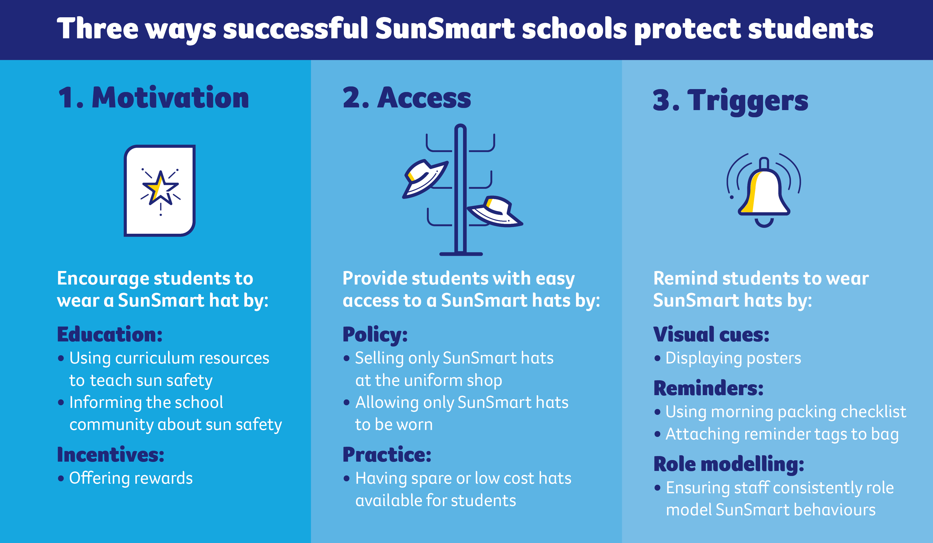

Firstly, Motivation. We’re encouraging SunSmart hat wearing by educating our students and ourselves.

Next we come to Access. Every student should have access to a SunSmart hat— and this is one key area where we need your help.

Last are Triggers. We are reminding students to wear their SunSmart hats every day.

9: Our plan

After looking at what we currently do in our school, the leadership team and I came up with a plan to help us reach our SunSmart goals.

[Insert Plan here. Please talk about your approach and what resources you will use at the school, which you will have decided when you completed your action plan]

It involves making sure that we are good role models, and importantly, it involves making sure that every child has access to both a good SunSmart hat and plenty of shade.

10: We need your help

We do everything we can in our school to make sure that our kids practise SunSmart behaviours. But as part of the local community, we need your support with funding for two vital parts of the SunSmart initiative.

The number one thing is: we need to make sure that every child has access to a SunSmart hat. We want them to have a hat that we know will protect them, which they can wear to school, at school, and on the way home from school every day. With your funding, we will be able to provide a SunSmart hat for every single child.

[OPTIONAL – use if applicable to your school] Secondly, your funding will help to create essential shade around the school. Because although hats protect the head and neck, they still leave kids’ arms and legs exposed to UV from the sun. So your funding can help to purchase shade sails for the playground and create other shady areas where kids can play without risk.

11: Give the kids of today a healthy tomorrow

Now that I’ve explained the damage UV rays can do and how we can prevent 95-99 per cent of skin cancer cases, I hope that you’ll decide to help fund our SunSmart initiative and provide [SunSmart hats and/or shade] for our school. With your funding, we can make sure that the kids of today will have a healthy tomorrow.

12: Thank you

Thank you.

For more information, contact SunSmart
Email: sunsmart@cancersa.org.au
Phone: (08) 8291 4265

